**Library Database Management System**

Submitted by

Sai Teja Bandaru 20BRS1129

Rohan Jacob John 20BRS1159

A project report submitted to

**Dr. Balasundaram A**

**SCOPE**

In fulfilment of the requirements for the course of

**CSE2004 – Database Management Systems**

In

**B.Tech Computer Science and Engineering**



**Vandalur – Kelambakkam Road**

**Chennai – 600127**

**DEC 2021**

**BONAFIDE CERTIFICATE**

Certified that this project report entitled “**Library Database Management System”**is a bonafide work of **Sai Teja Bandaru (20BRS1129) and Rohan Jacob John (20BRS1159)** who carried out the Project work under my supervision and guidance for **CSE2004 – Database Management Systems.**

**Dr. Balasundaram A.**

Assistant Professor (Sr.)

SCOPE

VIT University, Chennai

Chennai – 600 127.

**TABLE OF CONTENTS**

|  |  |  |
| --- | --- | --- |
| **SL. NO.** | **TITLE** | **PAGE NO.** |
| 1. | ABSTRACT | 4 |
| 2. | ACKNOWLEDGEMENT | 5 |
| 3. | INTRODUCTION | 6 |
| 4. | ER DIAGRAM | 7 |
| 5. | ER TO RELATIONAL MAPPING | 9 |
| 6. | IMPLEMENTATION | 11 |
| 6. | EXPERIMENTAL SETUP (HARDWARE & SOFTWARE SPECIFICATIONS ) | 12 |
| 7. | EXPERIMENTAL RESULTS DISCUSSION | 13 |
| 8. | CONCLUSION AND FUTURE WORK | 17 |
| 9. | REFERENCES | 17 |
| 10. | APPENDIX 1 (SQL QUERIES) | 18 |
| 11. | APPENDIX 2 (Relevant Screenshots) | 19 |

**ABSTRACT**

Maintaining the library records manually is not an easy task as it is a very slow process and could result in errors in the records. This would then lead to the reduction in the productivity of the library. Therefore, it is very crucial to have an efficient and effective database management system which would help both the librarians as well as the customers to access books at ease. Database management system will help to effectively manage the details of the books, members and transactions etc. It helps to organize the data which would help increase the productivity of the library and makes the work of the librarian much easier. Through the Library Database Management system, we aim to create a website which maintains all the details about the books present in the library, members, employees, transactions etc.

**ACKNOWLEDGEMENT**

We wish to express our sincere thanks and deep sense of gratitude to our project guide, **Dr. Balasundaram A.,**Assistant Professor (Sr.), SCOPE, for his consistent encouragement and valuable guidance offered to us in a pleasant manner throughout the course of the project work.

        We also take this opportunity to thank all the faculty of the School for their support and their wisdom imparted to us throughout the course.

        We thank our parents, family, and friends for bearing with us throughout the course of our project and for the opportunity they provided us in undergoing this course in such a prestigious institution.

 

Sai Teja Bandaru (20BRS1129) Rohan Jacob John (20BRS1129)

**INTRODUCTION**

A Library Management System is a software built to handle the primary housekeeping functions of a library. Libraries rely on library management systems to manage asset collections as well as relationships with their members.

The main purpose of this project is to make the work of the librarian easier by creating a database that can store details of the various books, members and transactions inside the library. This can also help in running the library with efficiency and at reduced operational costs. Such software eliminates the need for repetitive manual work and minimizes the chances of errors.

This website consists of various modules like Admin Registration/ Login / Logout, Members, Books and Transactions and it was created with the help of Bootstrap, MySql and PHP software. All these sections can help the librarian to manage the library in a more suitable and organised way as compared to the manual library systems. This project is designed to support librarians to record all the necessary details and to avoid the problem of book loss and files in the library.

**ER DIAGRAM**

The various entities used for this ER Diagram are: Books, Members, Librarian and Transactions.

Attributes:

* Book:- book_name, isbn, author, publisher, publication_dt, price.
* Members:- first_name, last_name, member_id, mobile, address, enroll_date, enroll_fee.
* Librarian:- fname, lname, librarian_id, phone, addr, email_id.
* Transactions:- transaction_id, date_of_issue, date_of_return, due_date, late_fee, mem_id, book_name.

Cardinality Ratios:

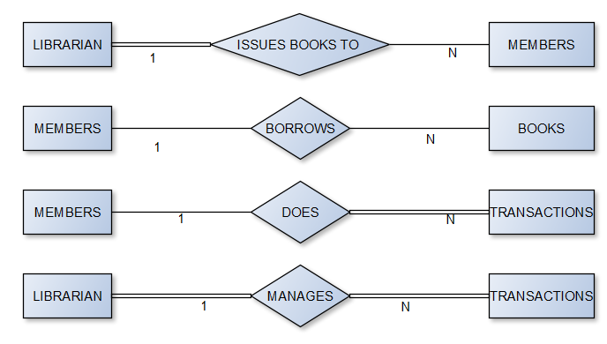

ER Diagram:

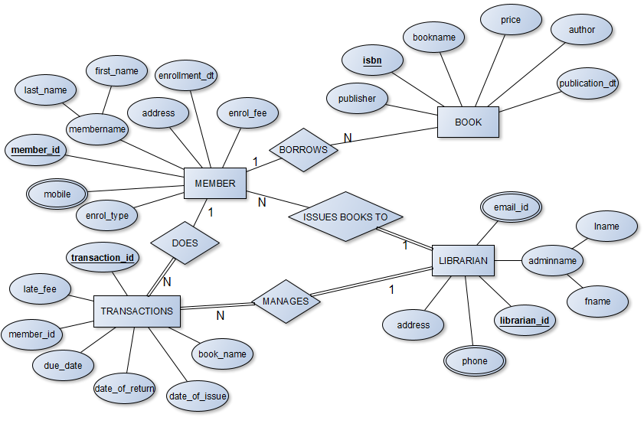

**ER TO RELATIONAL MAPPING**

Final ER To Relational Mapping:

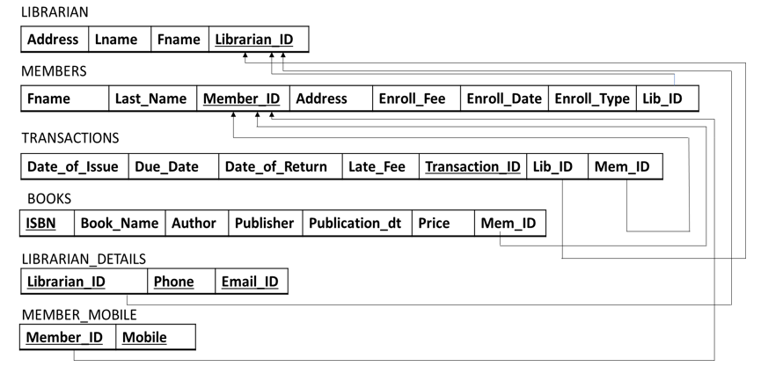

This was implemented with the help of 3 steps:

* Step 1: To create a corresponding relation for each regular entity that includes all the simple attributes and choose one of the key attributes as primary.
* Step 1 Result:

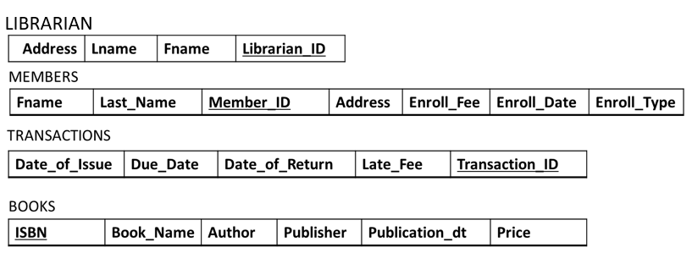

* Step 2: To choose “S” relation as the type at the N side of the relationship with the other as “T” and add as a foreign key to S all the primary key attributes of T.
* Step 2 Result:

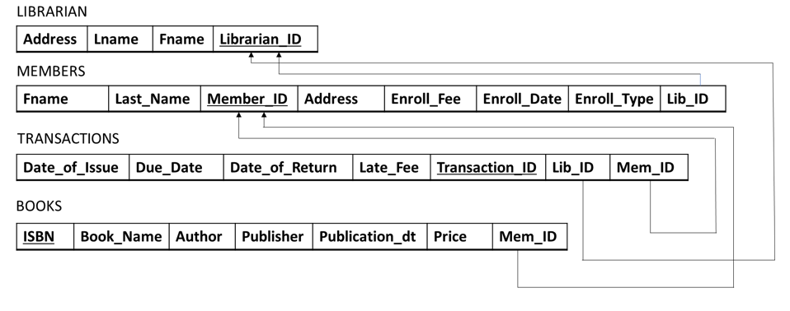

* Step 3: To create a new relation “S” to add the multivalued attributes and the primary key of the corresponding relation as foreign key and assign all attributes of S as primary key:
* Step 3 Result:



**IMPLEMENTATION**

The website uses HTML in front end with PHP as server-side scripting language, which will be used for database connectivity and the backend that is the database part, is developed using MySql. Bootstrap is also used in the front end to enhance the look and feel of the webpage.

User Interface Specifications:

Upon visiting the website the librarian will be able to see the following modules:

* Admin Registration/ Login / Logout Module: Admin will have the option for signing up or logging in with existing credentials. After the new admin creates an account, they will be redirected to the login page. Upon successful login, admin will be navigated to a home page where he/she can choose various menus from the website. Admin also has the option to logout of the webpage.
* Creating a new member: In this module, admin can add a member by capturing member name, type of subscription, no. of books borrowed, etc.
* Deleting a member: Admin also has an option to delete the member from the database.
* Displaying member details:  This module displays details of all the members registered in the library.
* Add books module: Admin can add Author, Book name, Publisher and Price details.
* Delete books module: In this module, admin can delete the book details of a specific book.
* Display books module: This module displays all the existing books available in the library.
* Add Transactions: Admin can issue the book to the member by keying in the book details, date of issue, due date etc
* Delete Transactions Module: In this module, admin will be able to delete any particular transaction of a member.
* Display Transactions: This module shows the history of the transactions made for a particular member.

**EXPERIMENTAL SETUP**

**HARDWARE SPECIFICATIONS:**

* Intel core i5 4th generation
* Hard Disk: 500 GB
* Ram 8 GB or more
* Windows 10 Operating System

**SOFTWARE SPECIFICATIONS:**

Database:

* MySQL: MySQL is one of most widely used open-source relational database management system. It runs as a server and allows multiple users to manage and create numerous databases.

Programming languages to be used for Web-page Design:

* HTML    : Mark-up-language for creating web pages and other information that can be displayed in a web browser.
* PHP - Open source, server-side, HTML embedded scripting language used to create dynamic web pages. PHP commands can be embedded directly into an HTML source document rather than calling an external file to process data. It has also evolved to include a command-line interface capability and can be used in standalone graphical applications.
* Bootstrap: Bootstrap is a free and open-source CSS framework directed at responsive, mobile-first front-end web development. It contains CSS- and JavaScript-based design templates for typography, forms, buttons, navigation, and other interface components.

**EXPERIMENTAL RESULTS DISCUSSION**

The library management system website has been successfully created. The following screenshots show the various features of the website:

Registration Page:

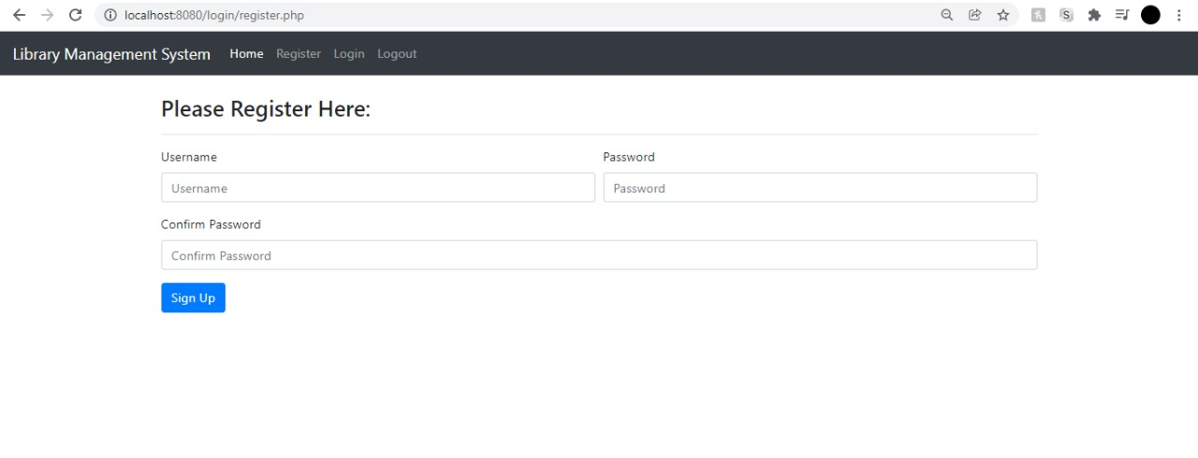

Login Page:

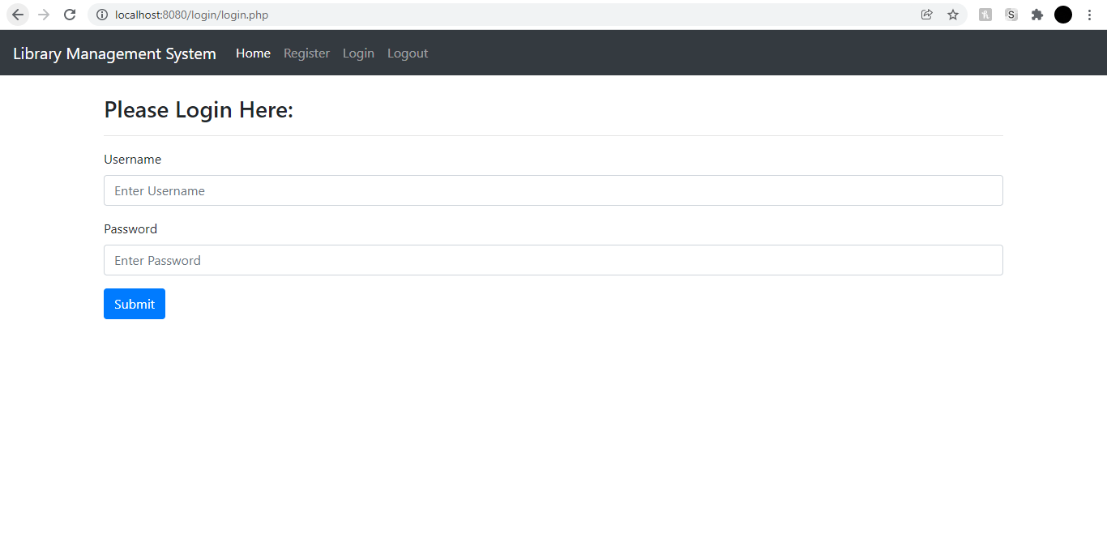

Contents Page:

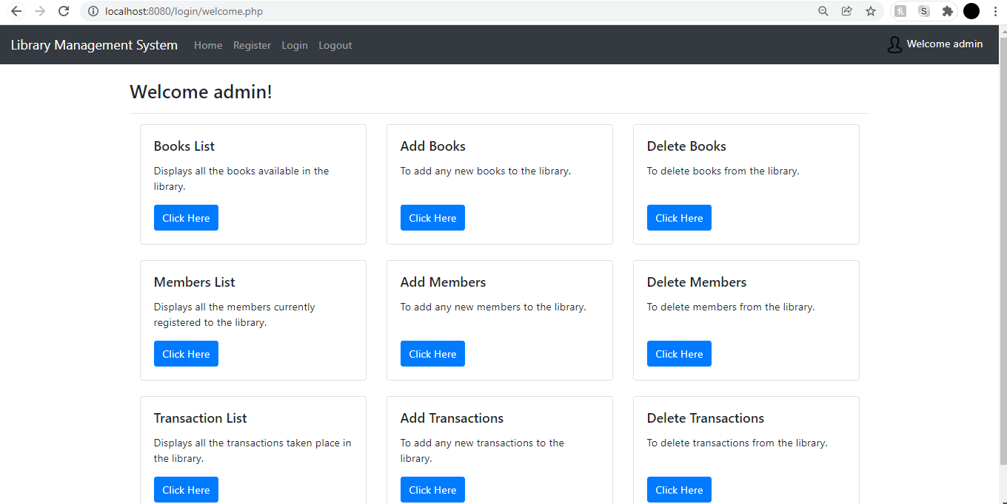

Adding Books:

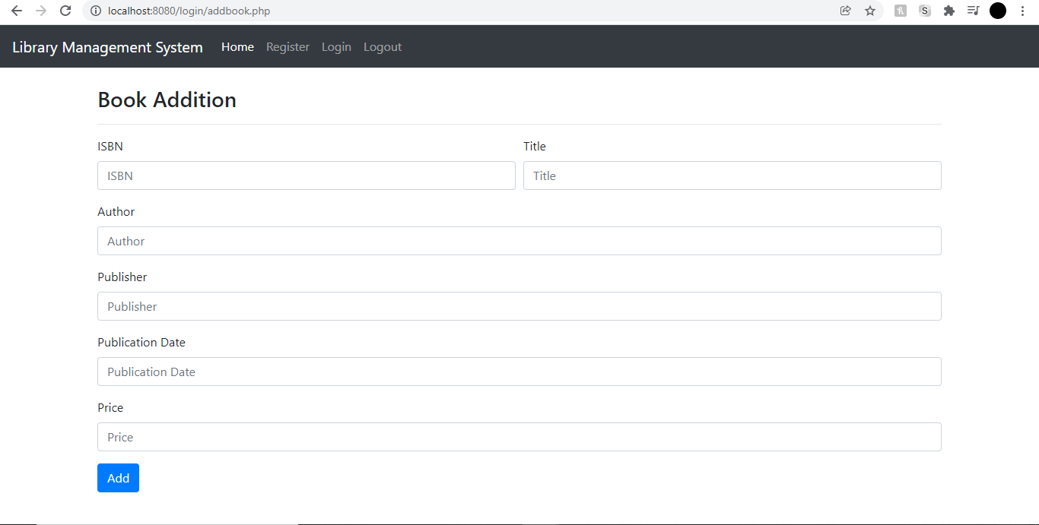

Adding Members:

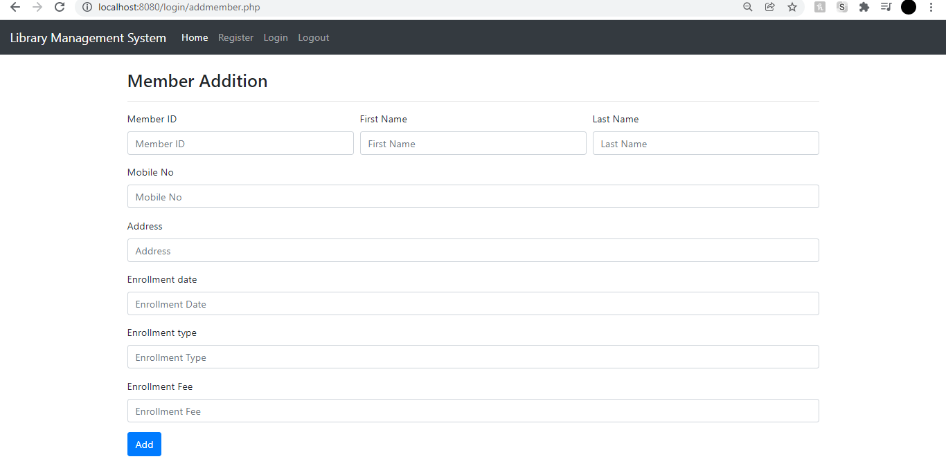

Adding Transactions:

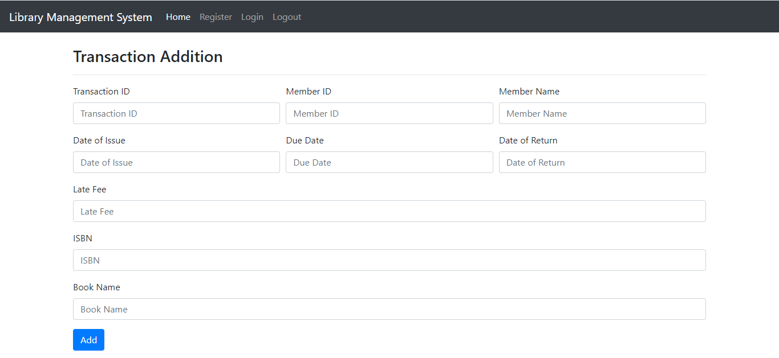

Deleting Books:

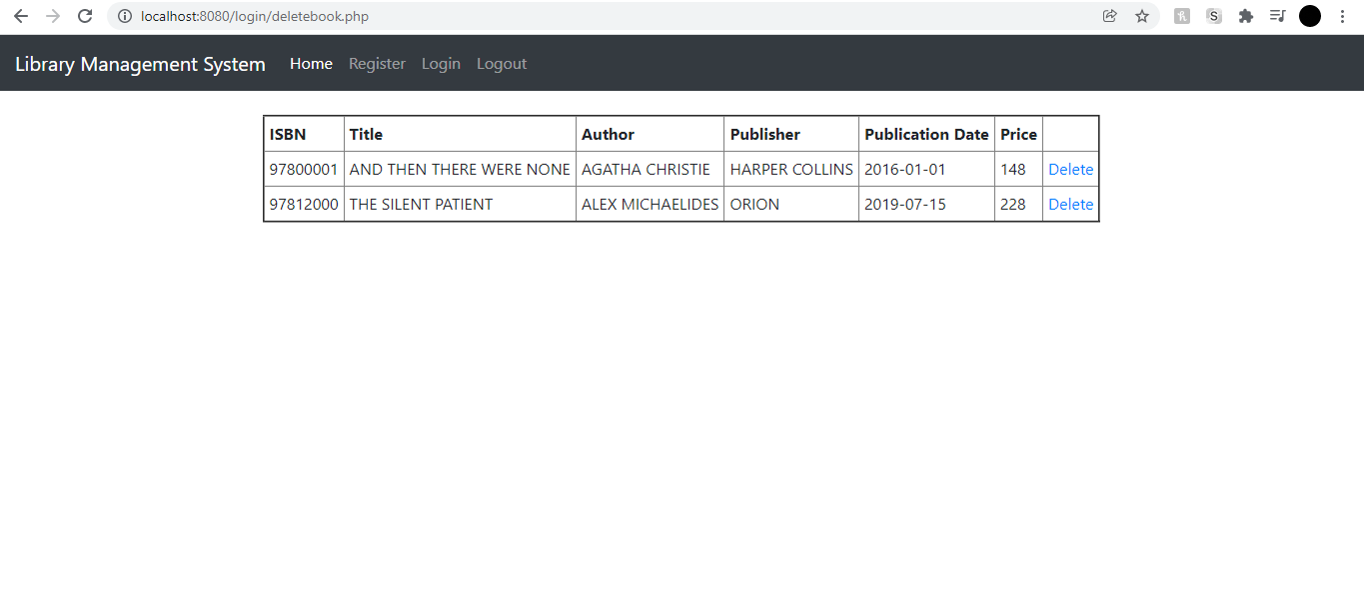

Deleting Members:

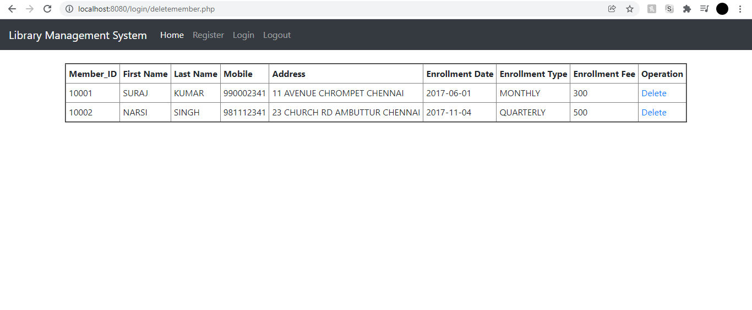

Deleting Transactions:

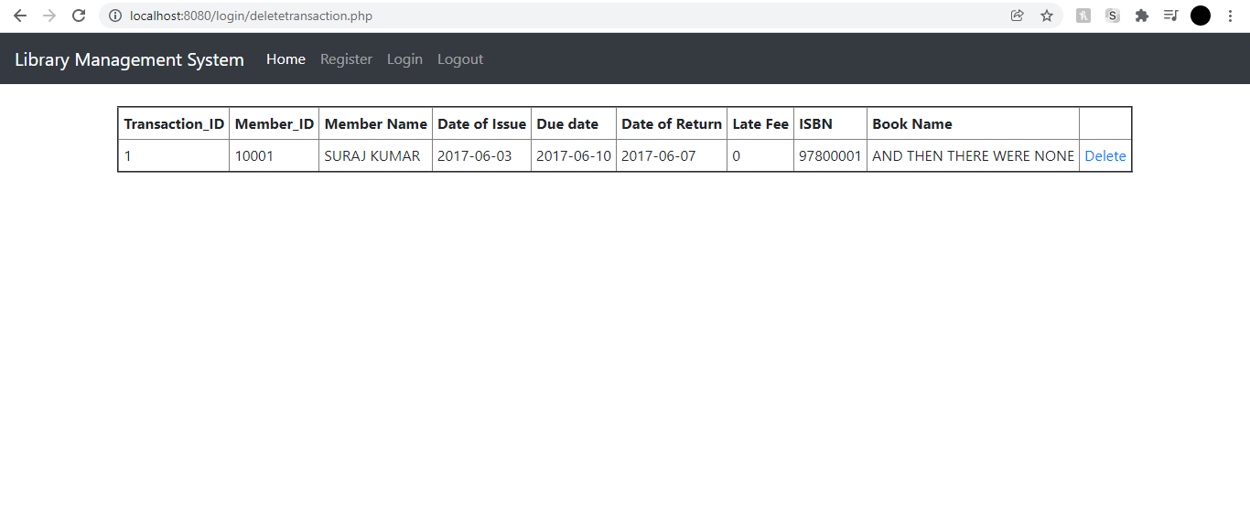

Books List:

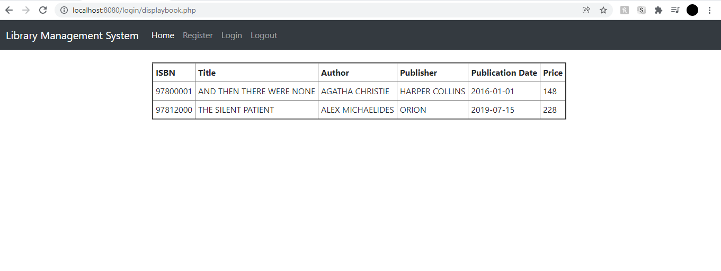

Members List:

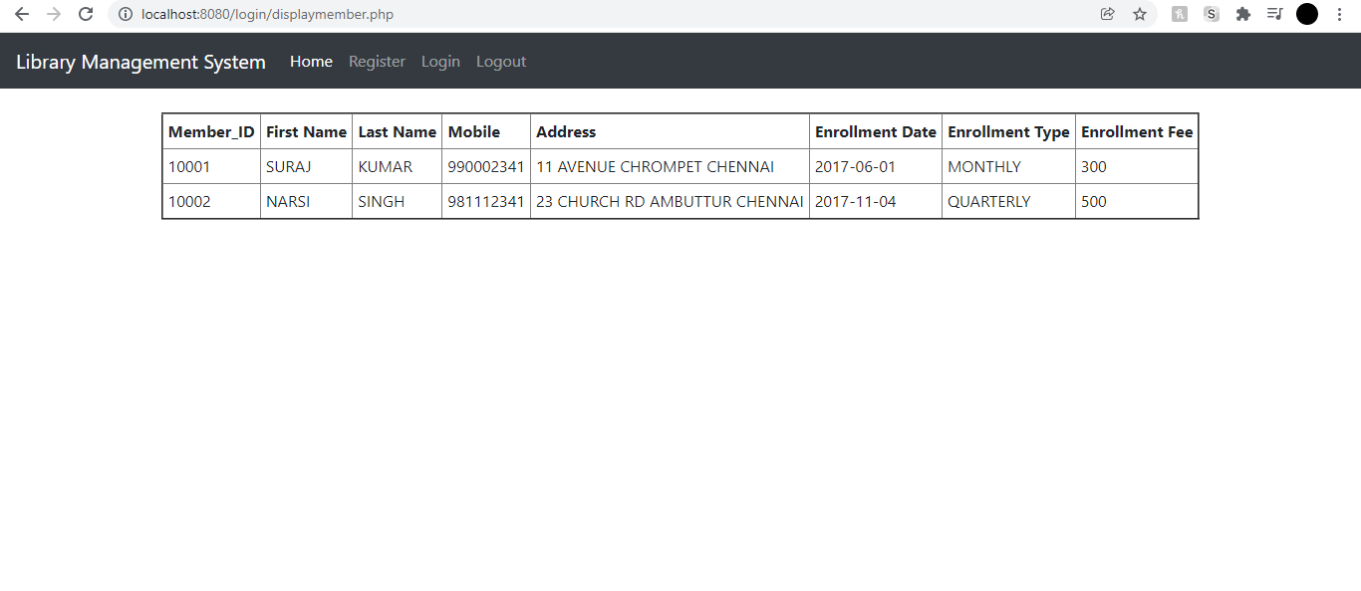

Transactions List:

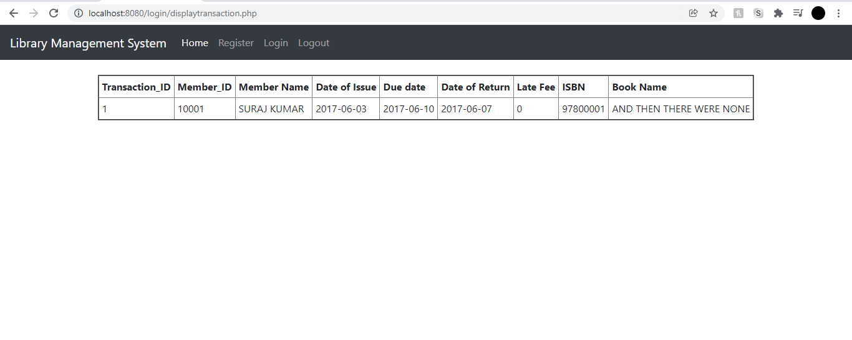

**CONCLUSION AND FUTURE WORK**

The main focus of this project is to lessen human efforts. The problems, which existed in the earlier systems, have been removed to a large extent. The computerization of the Library Management will not only improve the efficiency but will also reduce human stress thereby indirectly improving human resources.  The maintenance of the records is also made efficient, as all the records are stored in the MySql database, through which data can be retrieved easily. It can heavily benefit the librarians as they add and delete records at any time without worrying about loss of data and heavy paperwork.

**REFERENCES**

<https://www.javatpoint.com/what-is-bootstrap>

Tsega Weldu Araya, 2020. Designing Web-based Library Management System. *International Journal of Engineering Research and*, V9(10).

**APPENDIX I**

SQL Queries and Screenshots:



**APPENDIX II**

MySql and Php Code and Screenshots:



Database:

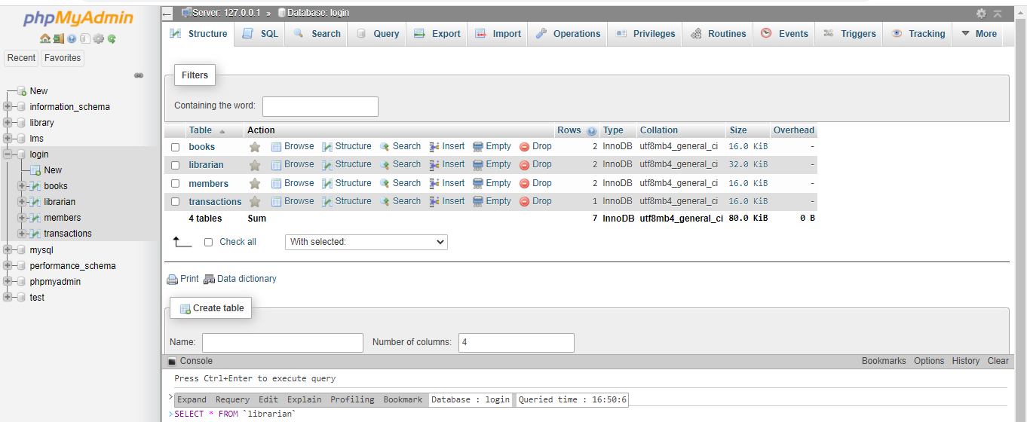

Books Table:

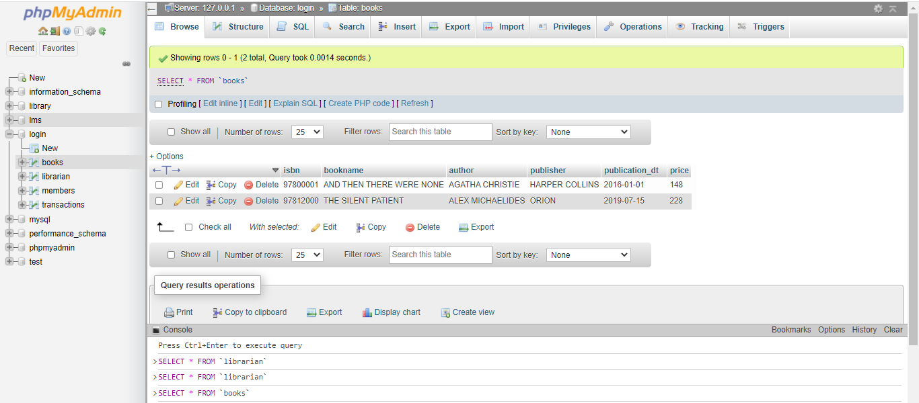

Librarian Table:

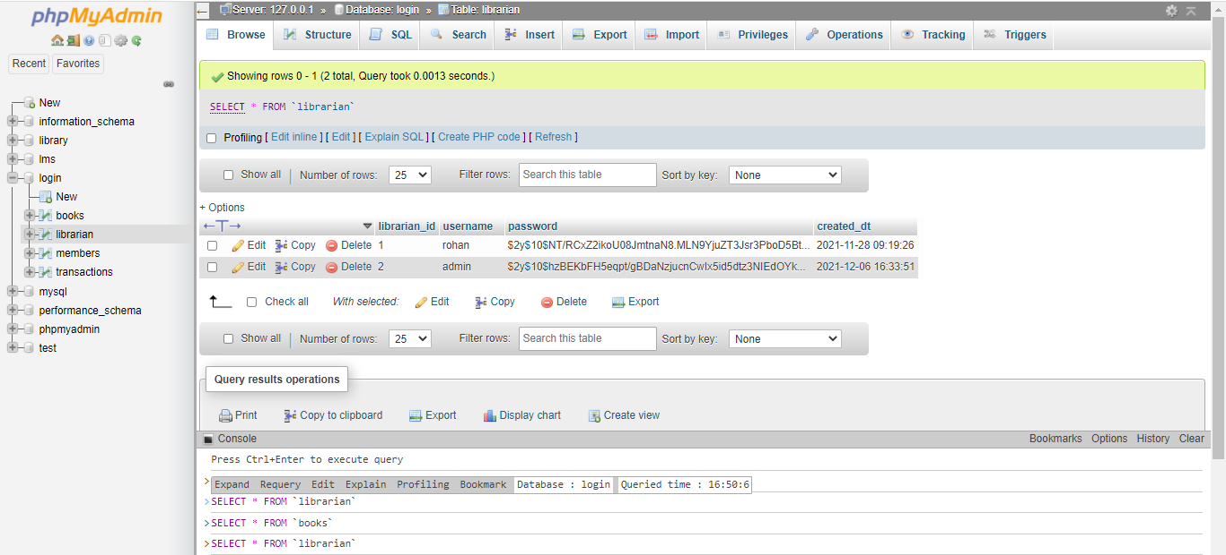

Members Table:

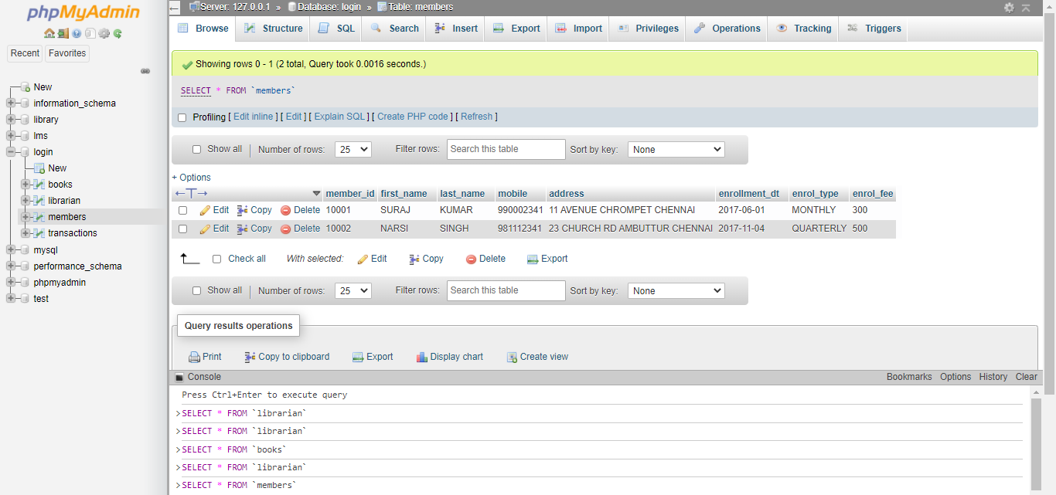

Transactions Table:

